Serial No. – STR/2025/029

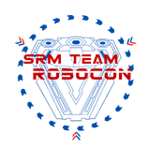

No Objection Certificate - Extension of In-Time

I, **Madhuri Naik**, Mother of **Jatin Naik** pursuing B.Tech in **Computer Science and Engineering w/s in AIML** at SRM Institute of Science and Technology hereby give consent for him to work in SRM Team Robocon, based out of Department of Electronics and Instrumentation Engineering.

For the duration of his involvement with SRM Team Robocon, the team would in no way be held responsible for the impact on his academic results/credits. I have no objection to his work at

ROBOCON Lab, Basic Engineering Lab 604, SRMIST.

I kindly seek an extension of his in-time up to **11:59 pm on weekdays, weekends, and holidays**, commencing from **27th January 2025 to 31st May 2025**.

This extension is solely for working with Team ROBOCON. The personal safety and well-being of my ward will be solely his responsibility while undertaking any of SRM Team ROBOCON’s tasks and neither the team nor SRM Institute of Science and Technology would in any way be held responsible for it.

This extension is required in order for my ward to increase his productivity, and contribute more to the output of the team.

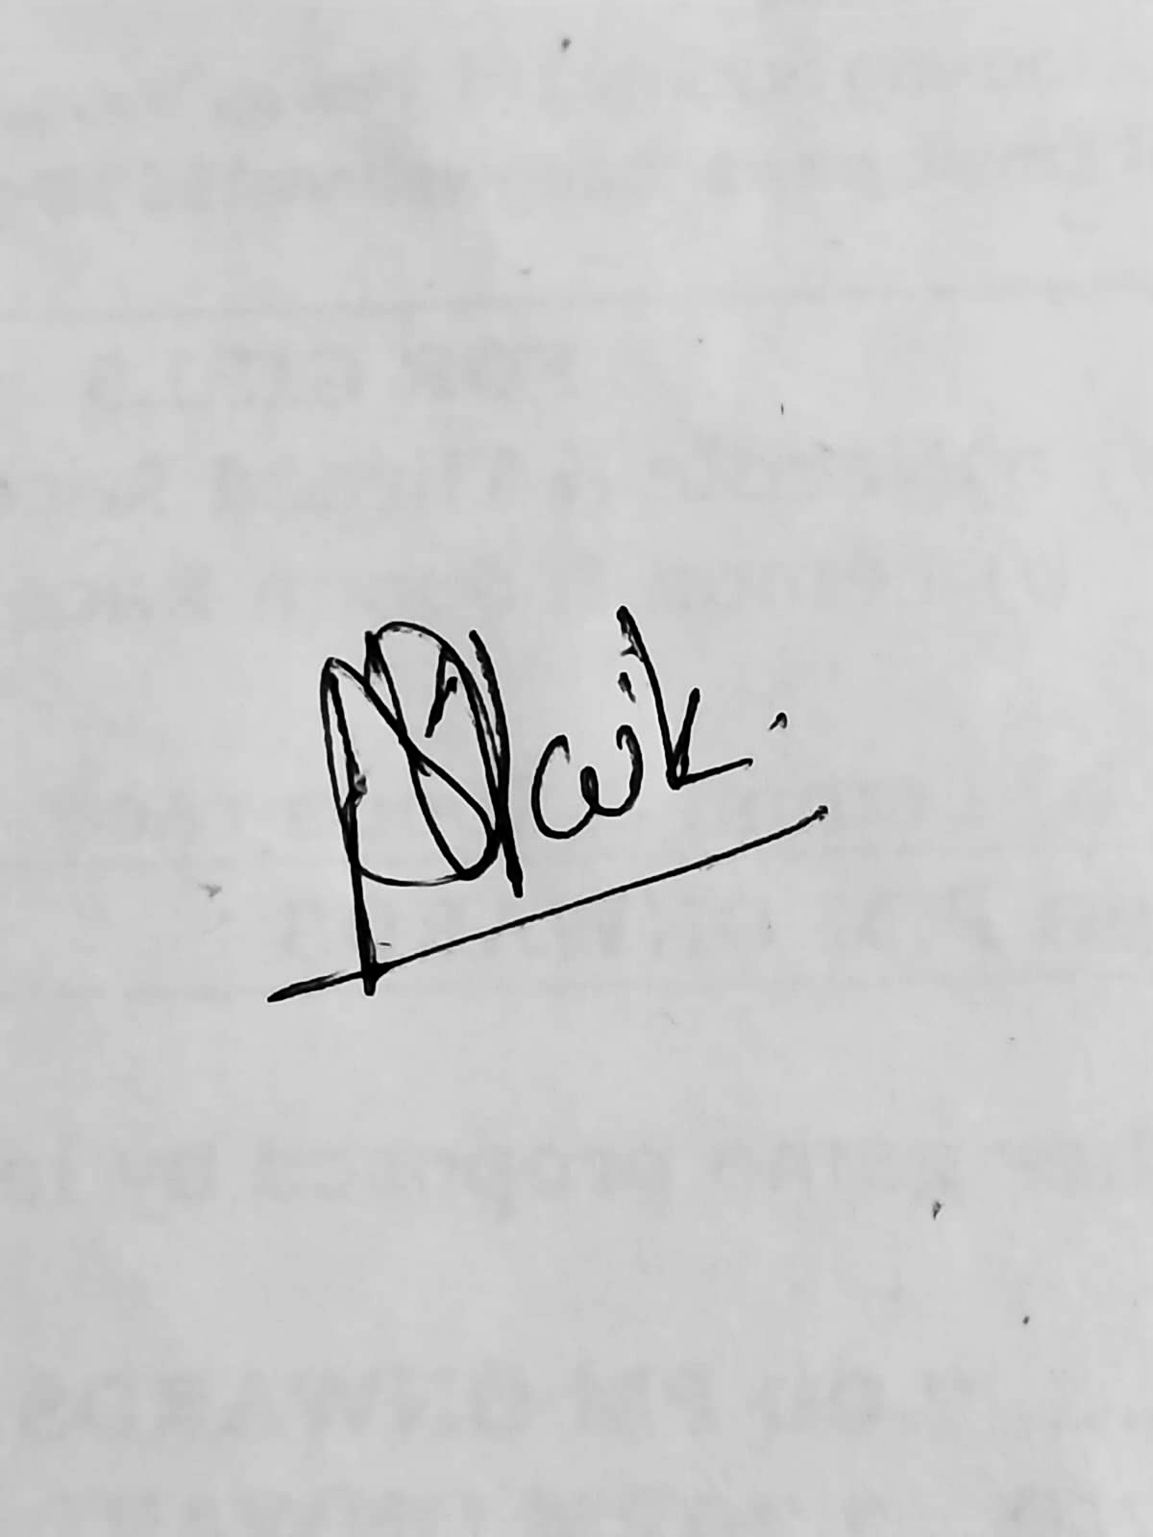

Signature of Parent/Guardian Dr. G.Joselin Retna Kumar Hostel Supervisor

HOD EIE Dept.

(Team Faculty Advisor)

Contact Number (Parent/Guardian): 9987018980

Email ID: jons.vvi@gmail.com

Address: 11/1, Pawan Baug, Mumbai-400064

SRM Team ROBOCON, 604, Fifth Floor, Basic Engineering Block, SRM Institute of Science and Technology, Kattankulathur, Chennai 60320